**SCHOOL OF COMPUTING (SOC)**

|  |  |
| --- | --- |
| **Date of Submission:** | Date of submission |

|  |  |
| --- | --- |
| **Prepared for:** | Fill in your tutor’s name |

|  |  |
| --- | --- |
| **Class:** | Fill in your class |

|  |  |
| --- | --- |
| **Submitted by:** |  |

|  |  |
| --- | --- |
| **Student ID** | **Name** |
| 1512345 | Alan Tan |
| 1513446 | Mary Lim |
| 1513447 | Jack Sng |

**IOT CA2**

**Step-by-step Tutorial**

**DIPLOMA IN BUSINESS INFORMATION TECHNOLOGY**

**DIPLOMA IN INFORMATION TECHNOLOGY**

**DIPLOMA IN INFOCOMM SECURITY MANAGEMENT**

**ST0324 Internet of Things (IOT)**

**2017/2018 Semester 1**

**Table of Contents**

Section 1 Overview of project 2

A. Where we have uploaded our tutorial 2

B. What is the application about? 2

C. How does the final RPI set-up looks like? 2

D. How does the web or mobile application look like? 2

Section 2 Hardware requirements 3

Hardware checklist 3

Section 3 Whatever your section header is 3

Section 4 Whatever your section header is 3

Section 5 Whatever your section header is 3

# Section 1 Overview of project

* 1. Where we have uploaded our tutorial

Paste the link here of your Youtube and tutorial document here

* 1. What is the application about?

Provide a brief description of your application here

* 1. How does the final RPI set-up looks like?

Provide a photo of your final RPI set-up

* 1. How does the web or mobile application look like?

Provide screenshots of your web app or mobile app and/or Telegram bot etc

* 1. System architecture of our system

Provide a hand-drawn or computer-drawn system architecture diagram please. Example given below.

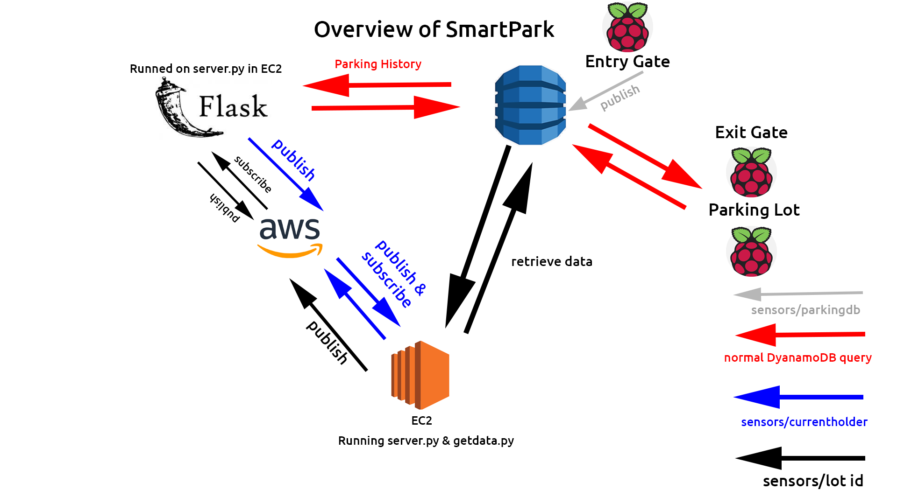

* 1. Evidence that we have met basic requirements

Provide bullet list to describe how your group has met basic requirements

|  |  |
| --- | --- |
| Requirement | Evidence |
| Used three sensors | Used xxx and yyy sensor. Also used zzzz,kkkk |
| Used MQTT | Our MQTT endpoint -->  Example of data sent through MQTT : ??? |
| Stored data in cloud | Stored light data in Cloudant database in IBM cloud |
| Used cloud service | Use AWS Rekognition, hosted web server on EC@ |
| Provide real-time sensor value / status | Show the real-time value of xxx sensor |
| Provide historical sensor value/ status | Show historical vlaue of yyyy sensor |
| Control actuator | Placed button on webpage to control zzz actuator |

* 1. Bonus features on top of basic requirements

Provide bullet list of the bonus features you have added on top of basic requirements

1. Log in systemthat zzzzz
2. Telegram bot that xxxx
3. SMS to alert user of xxxx
   1. Quick-start guide (Readme first)

Give a few lines of basic instructions on how I need to run your app, e.g

1. First connect hardware as in Section XXX
2. Then run the XXX.py file for web server
3. Run the xxxx.py for Telegram bot

# Section 2 Hardware requirements

Hardware checklist

# Section 3 Whatever your section header is

Whatever your section contents are

# Section 4 Whatever your section header is

Whatever your section contents are

# Section 5 Whatever your section header is

Whatever your section contents are

**-- End of CA2 Step-by-step tutorial --**